What Can NMR Teach Us About the Quantum Realm?

Brief Introduction to Quantum Mechanics

Table of Contents

*Expected Learning Outcomes* 2

Brief History of Quantum Mechanics 2

Observational Experiment 3

Individual Reflection 5

Small Group Discussion 5

Relating the Postulates of Quantum Mechanics to NMR 6

The State Vector Rule Postulate 6

Guided Inquiry Question 8

The Stationary State Postulate 8

Guided Inquiry Question 9

The Outcome Probability Postulate 9

Guided Inquiry Questions 10

The Superposition and Decoherence Postulate 11

Guided Inquiry Questions 11

Heisenberg Uncertainty Principle 12

Examples of Uncertainty Principles 15

Guided Inquiry Question 15

Testing Experiment 16

Guided Inquiry Questions 16

Reflection Questions 17

Cited Sources 17

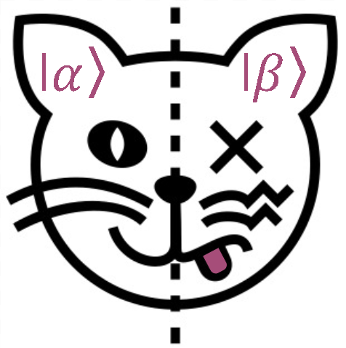

Modified from image source: Marco Petrucci, [CC BY 3.0](https://creativecommons.org/licenses/by/3.0), via Wikimedia Commons (1).

## *Expected Learning Outcomes*

*At the end of this module, students should be able to…*

1. *Connect important postulates of quantum mechanics to what we know about NMR*
2. *Interpret NMR experiments using quantum mechanics terminology*
3. *Predict how the resonance lineshape changes with longer pulses using the uncertainty principle*

**“I think I can safely say that nobody understands quantum mechanics.”**

— Richard Feynman

# Brief History of Quantum Mechanics

**Quantum Superposition** - a fundamental principle of quantum mechanics where a quantum system should be thought of as existing in all possible states until measured.

***PopSci Connection!*** **Schrödinger's Cat** - If quantum particles can exist in a superposition of states, there seems to be a level of absurdity behind it. Schrödinger’s cat was not meant as an example of quantum state collapse by outside observers or measurements, but instead as a teaching tool used to reveal the seemingly absurd interpretations of quantum theory. By placing a cat, which can either be alive or dead (depending on the quantum behavior of a radioactive particle) in a box, Schrödinger suggests that quantum theory would have us believe that it is not until the observer opens the box that a conclusion can be deduced whether or not the cat is alive or dead. If quantum particles can be in a superposition of states, what does this tell us about our physical reality?

The history of quantum mechanics is a large portion of the history of modern physics. Dating as far back as 1838 with Michael Faraday’s discovery of cathode rays, quantum mechanics began with a number of groundbreaking scientific discoveries. From Gustav Kirchhoff’s “black-body radiation” problem first proposed in 1859 to the introduction of the standard model of particle physics in the mid-1970s, for over a century, scientists have sought to understand and explain the phenomena of how subatomic particles exist and interact with one another. Most famously, Erwin Schrödinger’s 1922 publication describing **quantum superposition** - the ability of a quantum system to be in multiple states simultaneously until the system is measured - rattled many 20th-century physicists, including Schrödinger himself. As our understanding of quantum mechanics continues to take shape, new technologies such as quantum computing will revolutionize the way we think, work, and interact with the world around us.

# Observational Experiment

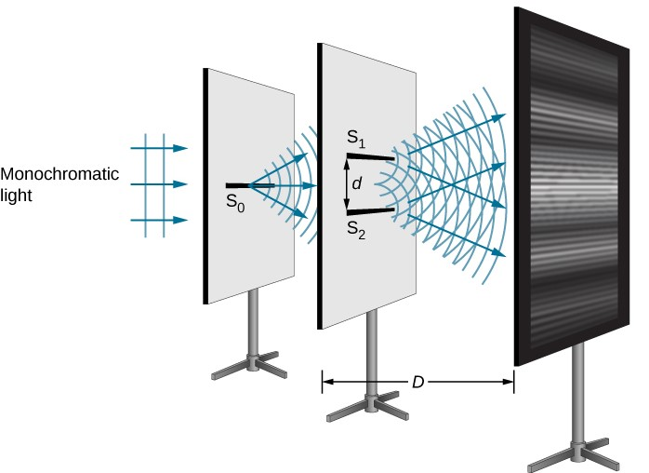

**Double slit experiment** experimental set up and results demonstrating the wave nature of light.  
Image source: OpenStax University Physics Volume 3, [CC BY-NC-SA 4.0](https://creativecommons.org/licenses/by-sa/4) (2).

The famous **double-slit experiment**, first performed by Thomas Young in 1801, proves the idea that photons of light consist of waves because light passing through the slits form an interference pattern. This begged the question, if light can also be modeled as individual particles (called photons), what will happen if we just shine one photon on the slits? A single photon would, presumably, only pass through one of the slits with 50/50 probability and then hit the screen directly opposite the slit it passed through. After multiple single photons pass through the slits, the resulting pattern on the screen would be two bright lines directly across from each slit, and distinctly different from the interference pattern seen when waves pass through the slits.

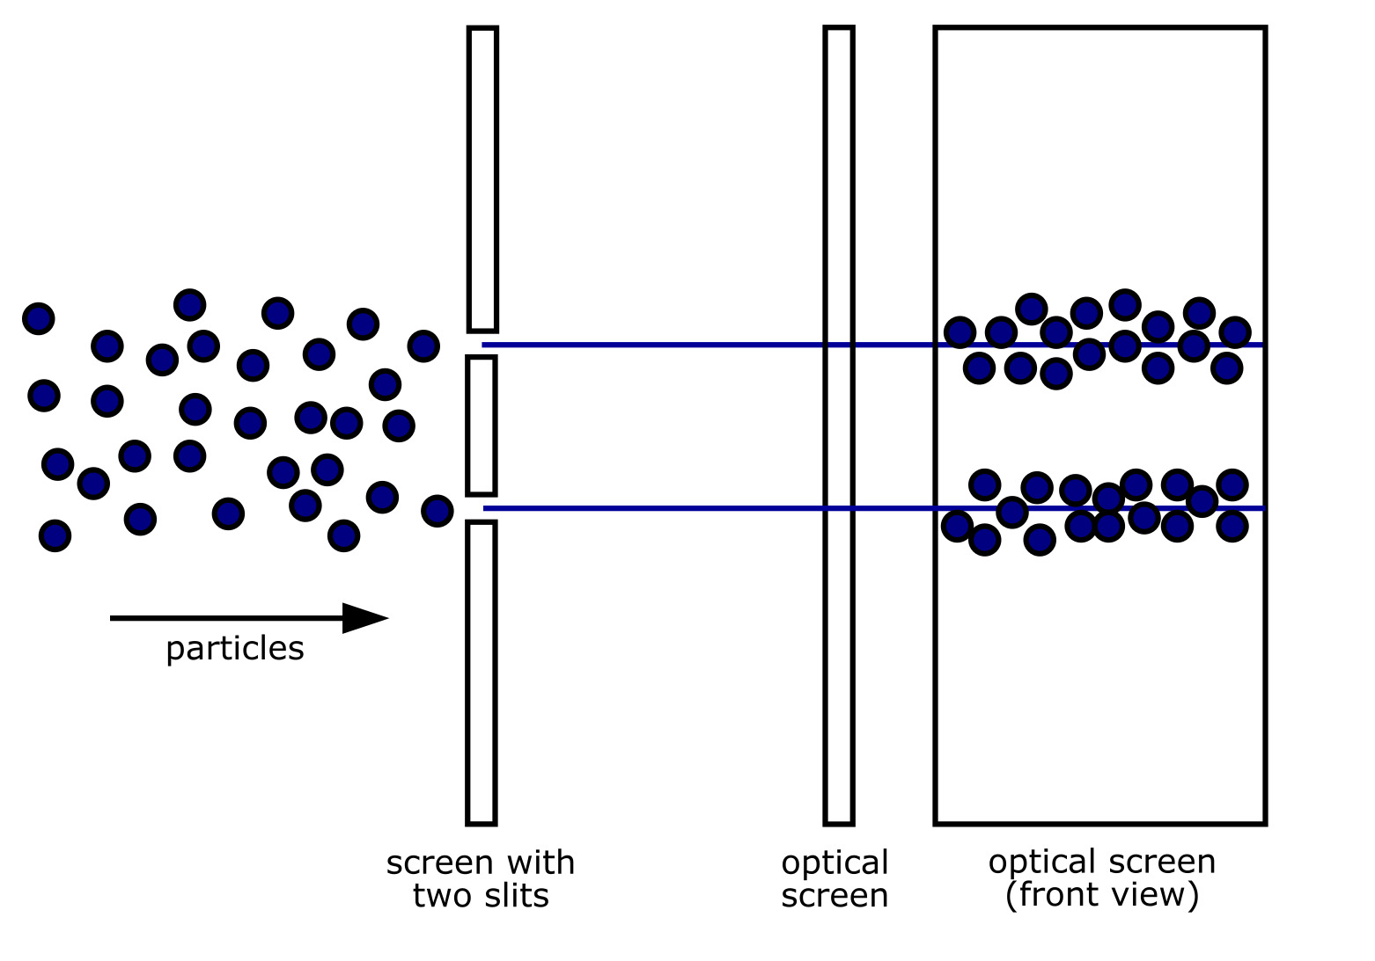

**Double slit experiment** experimental set up and *expected* classical results for particles passing through the two slits.  
Image source: inductiveload, Public domain, via Wikimedia Commons (3).

Performing the double-slit experiment with single photons appears to provide a way to differentiate the particle and wave nature of light. But the quantum realm is not one for straightforward answers. The results of a single-particle double-slit experiment are shown below.

Sending single photons through a double-slit and the emerging interference pattern builds up upon repeating the experiments thousands of times. Results of a double-slit experiment performed by Dr. Tonomura using single electrons. Numbers of electrons are (a) 11, (b) 200, © 6000, and (d) 140,000.  
Image source: Belsazar derivative work: MikeRun, [CC BY-SA 3.0](http://creativecommons.org/licenses/by-sa/3.0/), via Wikimedia Commons (4).

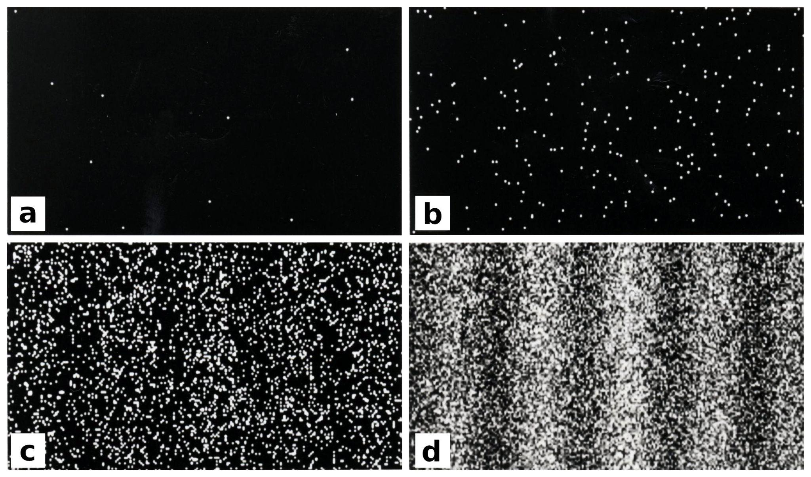

## Individual Reflection

1. Do these results support the wave-like nature of light?
2. Do these results support the particle-like nature of light?
3. What can these experimental results tell us about the quantum nature of light?

Each individual photon that goes through the double-slit apparatus is responsible for creating one of the small dots on the screen. Although each photon arrives as a single particle at some point on the screen, we can see that an interference pattern appears after multiple experiments - a *different pattern* than what you would expect if each single photon had just passed through one of the slits. The individual photons seem to ‘know’ where to go as if they were a wave that had passed through both slits.

Physicists have concluded from this (and many other experiments) that each single photon behaves as if it goes through both slits, interferes with itself and then lands on the screen as a single photon, causing an interference pattern to build up over time. A classical particle can only go through the left slit or the right slit, but a photon (or any quantum particle) is best described as being in a superposition of having gone through *both* the left and right slits.

This experiment not only demonstrates superposition of quantum states, but also shows that **superposition cannot be observed in action, but can be observed through its subsequent consequences.** In fact, when experimenters try to observe which slit the photon goes through, the interference pattern disappears, and you get the particle-like pattern that matches the measurement you made. When you make a measurement of a quantum particle, the quantum state collapses into one of its observable states, and quantum mechanics can only predict the *probability* of finding the particle in a given state.

The existence of quantum superposition and the probabilistic aspect of quantum theory may suggest to you that the theory is incomplete, but every experiment thus far has shown that quantum superposition is *necessary* to explain all the observed data and serves as a basis for many 21st-century technological advances like quantum computing.

## Small Group Discussion

1. What aspects of quantum superposition have you seen in the study of NMR already?
2. Is the quantum behavior of spins necessary for understanding and analyzing NMR data?
3. We have seen that interactions with the environment can cause the relaxation of quantum spins so that they are no longer in a superposition state. Provide a possible explanation of why we do *not* observe objects in a state of superposition outside of the quantum realm.

# Relating the Postulates of Quantum Mechanics to NMR

## The State Vector Rule Postulate

**state vector** - a vector in a complex vector space that contains all the information about the state of a quantum system.

**complex numbers** - Numbers made up of the combination of real numbers and purely imaginary numbers.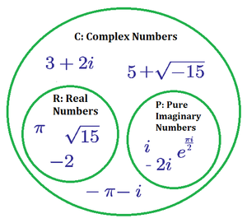

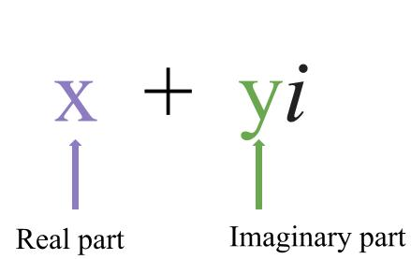

(Right) Image Source: Complex Numbers. Brilliant.org. Retrieved June 11, 2025, from https://brilliant.org/wiki/complex-numbers/ (5).

Quantum states can be represented as a **state vector**, $|Ψ⟩$, where $Ψ$ is often used in quantum mechanics to represent a generic state vector, and it is put inside a “ket”, $|⟩$, to remind us of its vector status. This state vector can have components that are **complex numbers**. Complex numbers are necessary and responsible for the ‘weirder’ aspects of Quantum Mechanics. “These complex numbers, usually they’re just a convenient tool, but here it turns out that they really have some physical meaning,” said Tamás Vértesi, a physicist at the Institute for Nuclear Research at the Hungarian Academy of Sciences.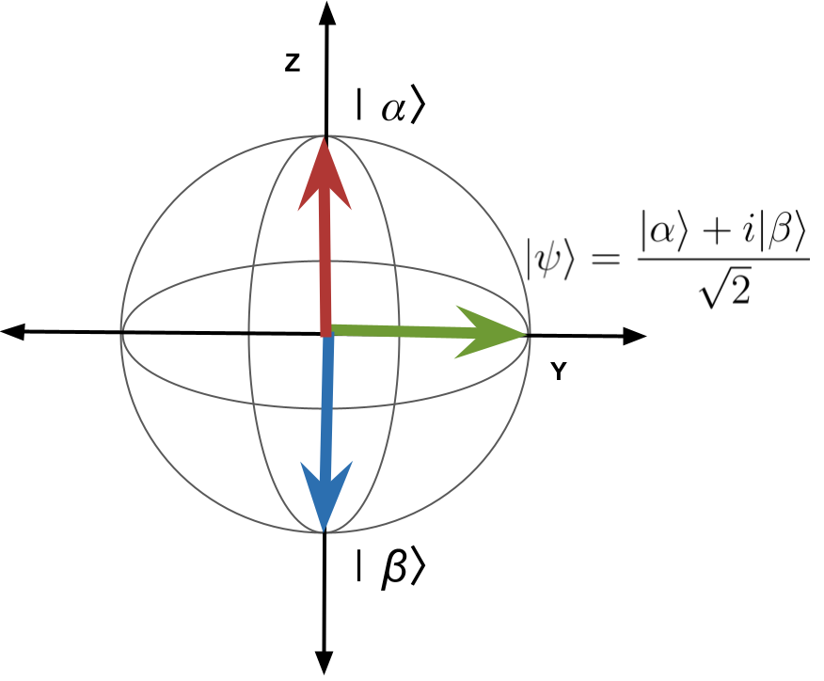

In NMR, we have seen the Bloch Sphere used to represent a two-level quantum system. The lower-energy spin-up state will now be represented by $|α⟩$, and the higher-energy spin-down state will be represented by $|β⟩$. A spin that is in a state of superposition is denoted by an arrow pointing at any other point around the sphere - for example, the state $|ψ⟩$ is a particular superposition of both $|α⟩$ and $|β⟩$ states. Notice that complex numbers naturally appear when writing $|ψ⟩$ as a combination of $|α⟩$ and $|β⟩$ states.

## Guided Inquiry Question

1. Do the spin-1/2 state vectors represented on the Bloch sphere reside in a real or complex vector space? Explain your reasoning.

## The Stationary State Postulate

**observables** - physical quantities of a quantum state that can be measured

**stationary state** - quantum state that is associated with a measured observable

Physical quantities that can be measured of a quantum state (such as position, momentum, energy, or spin) are called **observables**. Each possible observable value that results from a measurement has an associated state vector, called a **stationary state**. When a measurement is made, the quantum state is said to ‘collapse’ into the stationary state associated with the observable value. The state is considered ‘stationary’ because a quantum system will stay in that state indefinitely until the system is interacted with (by the environment or another measurement being made).

Examples of observables for quantum spins are measurements of the spin angular momentum ($\vec{S}$) and the spin state, characterized by the spin magnetic quantum number ($m_{s}$). An example of making a measurement for a quantum spin would be passing that spin through a Stern-Gerlach device and seeing where it gets deflected. For a spin-1/2 particle the spin will only be found to be either deflected up or down into the two possible stationary states ( $|α⟩$ or $|β⟩$) associated with the magnetic spin quantum number observable with values of $m_{s}=+1/2$ or $m_{s}=-1/2$, respectively.

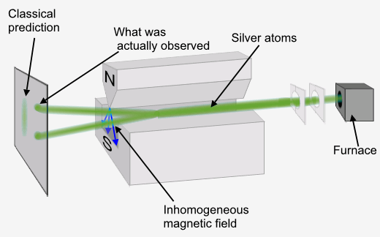

Image modified from source: Tatoute, [CC BY-SA 4.0](https://creativecommons.org/licenses/by-sa/4.0), via Wikimedia Commons (6).

## Guided Inquiry Question

1. Consider the three spin-1/2 quantum states shown in the Bloch sphere above. Which states would be considered stationary states? Explain your reasoning.
2. What observables are associated with the stationary states you identified in the previous question?

## The Outcome Probability Postulate

**probabilistic** - uses probability to calculate the likelihood of an event to occur

**non-deterministic** - can produce different results for the same input and so cannot make an exact prediction of the result for a given input

**expected value** - the weighted average of all the possible values that measurement can take

Quantum theory is **probabilistic** and **non-deterministic**. Quantum Mechanics provides scientists with a way to mathematically calculate the probability of finding a quantum system in a particular state and also predicts how that probability changes in time if the state is left alone or measured in various ways. Before quantum mechanics, if one knew the position and momentum of an object for one instance in time (along with all the forces acting on that particle), one could accurately predict the position and momentum of that object for all future moments in time. Using this classical understanding of mechanics, we could predict where cannon balls, and even rockets, would end up with great accuracy. However, according to quantum mechanics, even if you know the position and momentum of a quantum particle to the best of your measurement capabilities at the current moment, quantum mechanics cannot predict exactly what the position or momentum of the particle will be in any future moment. Quantum mechanics can only provide the *probabilities* of finding the quantum particle within a range of positions and momentum values. At first glance, this might suggest that quantum mechanics is incomplete because it cannot give us the more complete picture we are used to in the non-quantum realm. However, multiple experiments suggest that this uncertainty in measurements is a more truthful representation of the physical world than our previous ‘classical’ laws of physics.

Although quantum mechanics cannot predict *exactly* the result of a single measurement of a particular quantum system, it still provides very helpful and accurate information. We have already seen the probabilistic nature of quantum mechanics. Recall that for a spin-1/2 particle in a magnetic field, if the spin is in a quantum state that resides in the upper hemisphere of the Bloch sphere, there will be a higher probability of measuring that spin in $|α⟩$. In fact, the closer the spin state on the Bloch sphere is to $|α⟩$, the higher the probability will be that the spin will be measured in $|α⟩$.

Along with probabilities, one can also use quantum mechanics to calculate the **expected value** of a measurement, and this will be equal to the average value of the results after doing multiple repeated experiments on individual quantum systems, or averaging the results over a large number of identical quantum systems. How the expected values of a measurement of a quantum system change with time is deterministic and can be as predictable as measurements in classical mechanics.

NMR makes measurements over a very large number of quantum spins (typically ${10}^{19}$ spins or above), so the expected values of an NMR measurement calculated using quantum mechanics are extremely accurate. The Bloch equations essentially give us deterministic equations of how the expected value of the quantum state of a spin-1/2 particle in the presence of a magnetic field will change in time, and this accurately predicts the experimental results we get in NMR when we are measuring the average spin state over a large number of quantum spins.

## Guided Inquiry Questions

1. If you wait a long time, what state would you predict the spin-1/2 particle to be in? Explain.
2. If you apply a 180-degree pulse to a spin initially in $|α⟩$, what state would you predict the spin to be in after the pulse?
3. Provide a pulse sequence you could use to put a spin initially in $|α⟩$ into a superposition state like $|ψ⟩$ in the Bloch sphere above.

## The Superposition and Decoherence Postulate

**quantum decoherence** - the process by which information of a quantum system is altered by the system's interaction with its environment, usually a quantum superposition state changing to a stationary state

The quantum state of a quantum system is only known once it is measured. If the system is not measured, it resides in a superposition of all possible stationary states. Unlike stationary states, superposition states are always time-varying. Interactions with its environment cause **quantum decoherence**, where, given enough time, the quantum system will tend towards the most probable stationary state.

The $T_{1}$ and $T_{2}$ relaxation processes in MR are examples of decoherence via quantum spin interactions with the local magnetic environment. As a result of relaxation, the quantum state of a spin-1/2 particle in a magnetic field will always tend towards the most probable stationary state ($|α⟩$).

## Guided Inquiry Questions

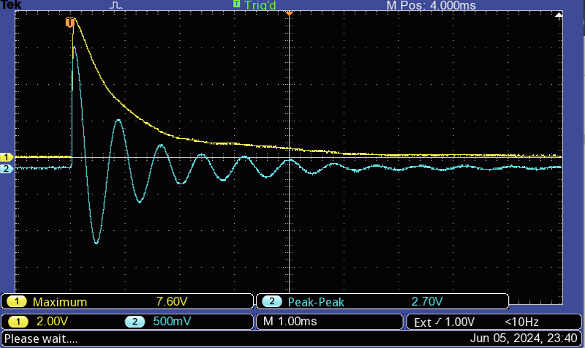

1. The figure above shows the result of a free induction decay (FID) experiment of protons in a sample of mineral oil. Is this an example of decoherence? Why or why not?
2. How does the time-varying nature of a precessing quantum spin suggest that the spin is *not* in a stationary state, but instead in a superposition state? Does this agree with which states we know will and will not precess in the Bloch sphere representation?
3. Physicists use multiple-pulse sequences like the Hahn echo or CPMG to “increase the coherence time”. What do you think they mean by that? Why might that be useful?

# Heisenberg Uncertainty Principle

**Werner Heisenberg** - Werner Heisenberg was a German theoretical physicist who was one of the pioneers of quantum mechanics. Beginning with breakthrough work first published in 1925, Heisenberg is best known for his uncertainty principle, also known as "Heisenberg's Uncertainty Principle," which won him the Nobel Prize in Physics in 1932 for "the creation of quantum mechanics." He would go on to become a principal scientist in nuclear physics, including being a key player in the Nazi nuclear weapons program in World War II.  
  
After his death in 1976, his wife, Elizabeth Heisenberg, characterized Heisenberg as, "first and foremost, a spontaneous person, thereafter a brilliant scientist, next a highly talented artist, and only in the fourth place, from a sense of duty, homo politicus." (7)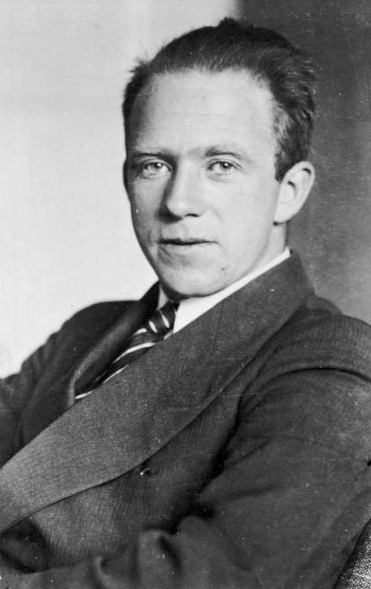

Image source: Bundesarchiv, Bild 183-R57262 / Unknown author / [CC BY-SA 3.0 DE](https://creativecommons.org/licenses/by-sa/3.0/de/deed.en), via Wikimedia Commons (8).

"What we observe is not nature itself, but nature exposed to our method of questioning."  
- Werner Heisenberg (9)

One of the most fascinating principles that naturally comes out of quantum mechanics is the uncertainty principle, famously formulated by Heisenberg. The most famous uncertainty principle states that it is impossible to measure or calculate exactly both the position ($x$) and the momentum ($p$) of an object. More mathematically, the product of the uncertainties ($ΔxΔp$) must be non-zero but can be *very* small on the order of $ħ∼{10}^{-34}$.

**Highlights of some of Heisenberg’s Uncertainty Principles:**

$$ΔxΔp≥\frac{ℏ}{2}$$

$$ΔEΔt≥\frac{ℏ}{2}$$

Macroscopically, Heisenberg’s principle is widely ignored, often because we cannot measure the position or momentum of a macroscopic object with enough precision where the uncertainty principle would be noticeable. However, the quantum world relies on this principle. A precision measurement of position (that is $Δx→0$) automatically indicates a larger error in the measurement of momentum (that is $Δp→∞$), and vice versa.

As a useful analogy, consider the graphic of the rollercoaster above. When the rollercoaster reaches the crest of the track, we can measure its position fairly accurately at that instance in time, but doing so would not provide us with much information about its speed at that particular instance in time. As the rollercoaster descends the track, we can measure its speed as it passes two points along the track, at the cost of becoming less certain of its precise position when it is at that speed. Heisenberg’s uncertainty principle illustrates that the more we know about a particle’s position, the less we may know about its speed and vice versa.

There is a less common, but also very important, uncertainty relationship between energy and time, $ΔEΔt≥ħ/2$. The longer you observe the system ( $Δt$ larger) then the more certain you are about the system’s energy ( $ΔE$ smaller). If you make very short observations ( $Δt$ smaller), then your uncertainty in the system’s energy goes up ( $ΔE$ larger).

## Examples of Uncertainty Principles

In the quantum world, suppose you measure the position of an electron by shining a light on the electron. To detect the position of the electron, a photon from the light source must collide with the electron and deflect to the measuring device. Because photons hold some finite momentum, the collision between the photon and the electron will transfer momentum from the photon to the electron, thus increasing the electron’s momentum. Thus, any attempt at measuring the position of the electron will increase the uncertainty value of the momentum.

In the macroscopic world, the example can be applied to basketball. While measuring the position of the basketball, there is still a transfer of momentum from the photons to the ball, but because the mass of the photon is much smaller than the mass of the basketball, any transfer of momentum from the photon to the ball is negligible. Regardless, you cannot make that measurement with 100% certainty. (Especially if you consider the fact that the measurement device is also made up of quantum particles, so even interactions between the returning photons and the measuring device will be inherently uncertain!)

Radioactive decay and half-lives are related to the energy-time uncertainty principle. There will always be more of a population in the lower energy levels than the higher energy levels, because they spend less time in the higher energy levels and more time in the lower energy levels. In quantum mechanics, the exponential decay times are inversely proportional to the energy, so the larger the energy, the shorter the decay time.

## Guided Inquiry Question

1. Stationary states are not time-varying, so we know that the quantum system will stay in those states until acted upon ( $Δt→$ very large). What does the energy-time uncertainty principle then tell us about our uncertainty in the *energy* of a stationary state?

# Testing Experiment

Here we will perform an NMR experiment to see if the energy-time uncertainty principle applies to our quantum spins. We will set up a standard FID experiment using either a 90-degree pulse or a 450-degree pulse (effectively increasing $Δt$). To determine $ΔE$, we will look at the resonance response curve by plotting the amplitude of the FID signal for pulses sent at different frequencies around the Larmor frequency. Since the energy of the electromagnetic radiation being sent by the pulses is directly proportional to the frequency, $ΔE$ is also directly proportional to $Δf$.

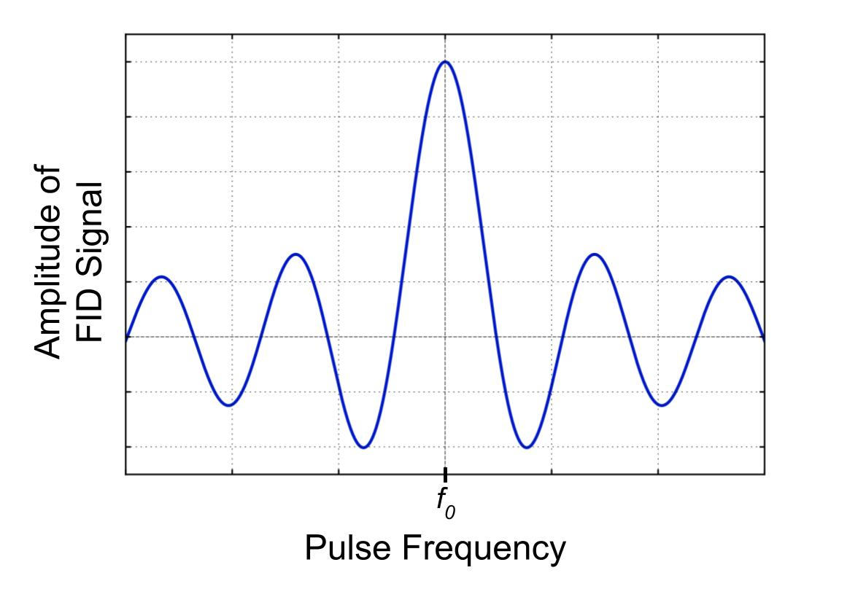

Note that classically, one would only predict a single peak, but for quantum systems, we can predict the existence of the side lobes using quantum mechanics.

## Guided Inquiry Questions

1. Thinking about the dynamics of spins along the Bloch sphere using the [Bloch simulator](https://www.drcmr.dk/BlochSimulator/), do you expect the MR signal amplitude to be different if you use a 450-degree pulse instead of a 90-degree pulse? Explain your reasoning.
2. The Bloch simulator pulses assume the pulses are sent at the Larmor frequency of the spins (often called “on-resonance”). But now we will be deliberately driving the spins “off-resonance” to see the resonance curve. Using the energy-time uncertainty principle, do you expect the width of the resonance peak (directly proportional to $Δf$) to increase or decrease when you use the 450-degree pulse instead of the 90-degree pulse?
3. Check out the results of the experiment [here](https://docs.google.com/document/d/1RHVnelv7SdAmcSVdDilSEx9RDyXgZM09aj864OBsb1o/edit?usp=sharing) or view the frequency-domain curves below. Does this agree with the energy-time uncertainty principle?

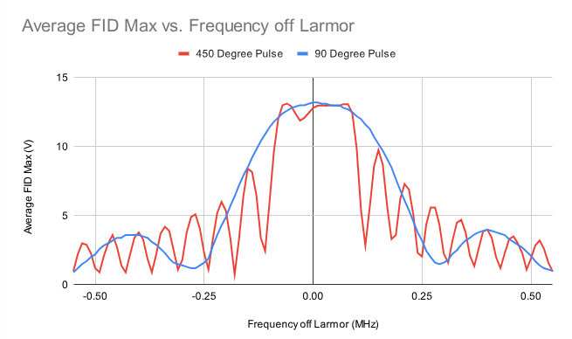

# Reflection Questions

1. Provide three examples of how elements of NMR we have studied directly connect to important postulates of quantum mechanics.
2. Write a short response in agreement or disagreement to the following statement: “The fact that quantum mechanics is probabilistic and the predictions inherently uncertain means that it is an inferior theory to classical mechanics where predictions are deterministic and exact.”
3. NMR is one application of quantum theory that has made an important scientific impact. Check out other technologies that have come out of our understanding of quantum mechanics, in the Forbes article [“What has quantum mechanics ever done for us?”](https://www.forbes.com/sites/chadorzel/2015/08/13/what-has-quantum-mechanics-ever-done-for-us/). Pick one of these technologies and briefly describe its scientific and/or cultural impact.

## Cited Sources

1. <https://commons.wikimedia.org/wiki/File:Kato_de_Schr%C3%B6dinger_Noun-8640.svg> “Wikimedia Commons: Schrödinger’s cat”
2. <https://openstax.org/books/university-physics-volume-3/pages/3-1-youngs-double-slit-interference> “OpenStax University Physics Volume 3: Young’s Double-Slit Interference”
3. <https://commons.wikimedia.org/wiki/File:Two-Slit_Experiment_Particles.svg> “Wikimedia Commons: Two-Slit Experiment Particles”
4. <https://commons.wikimedia.org/wiki/File:Double-slit_experiment_results_Tanamura_4.jpg> “Wikimedia Commons: Double-slit experiment Tanamura 4”
5. <https://brilliant.org/wiki/complex-numbers/> “Complex Numbers”
6. <https://commons.wikimedia.org/wiki/File:Stern-Gerlach_experiment.svg> “Stern-Gerlach Experiment”
7. <https://en.wikipedia.org/wiki/Werner_Heisenberg> “Werner Heisenberg”
8. <https://commons.wikimedia.org/wiki/File:Bundesarchiv_Bild183-R57262,_Werner_Heisenberg.jpg> “Wikimedia Commons: Werner Heisenberg”
9. <https://scienceexchange.caltech.edu/topics/quantum-science-explained/uncertainty-principle> “What Is the Uncertainty Principle and Why Is It Important?”